* **[Review] How to calculate the interquartile range**

What is the IQR of the following data?



* **The 1.5 x IQR Rule for Outliers**

Call an observation an outlier if it falls outside the interval ____________________________

* **Example**【**NC workers**】

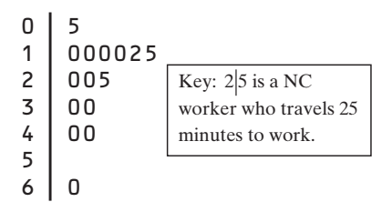 Determine whether there are outliers.

* **Practice【Shoes】**

How many pairs of shoes does a typical teenage boy own? To find out, two students surveyed a random sample of 20 male students from their large high school and recorded the number of pairs of shoes that each boy owned. Here are the data, along with a dotplot:

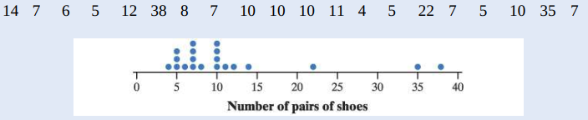

Describe the procedure for identifying outliers, and use the procedure to decide whether there are outliers.

* **Five-number summary**

The **five-number summary** of a distribution consists of _________________________________________________

* **Boxplot (also called _____________________________________)**
* **Example**【**NC workers**】

Barry Bonds set the major league record by hitting 73 home runs in a single season in 2001. On August 7, 2007, Bonds hit his 756th career home run, which broke Hank Aaron’s longstanding record of 755. By the end of the 2007 season when Bonds retired, he had increased the total to 762. Here are data on the number of home runs that Bonds hit in each of his 21 complete seasons:  
16 25 24 19 33 25 34 46 37 33 42 40 37 34 49 73 46 45 45 26 28

1. Find the ________________________
2. Identify the ______________
3. Make a __________

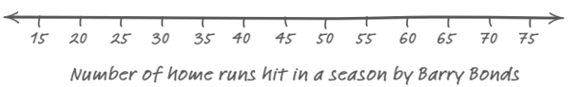

* **Practice**【**NY workers**】New York travel time data:

10 30 5 25 40 20 10 15 30 20 15 20 85 15 65 15 60 60 40 45

Draw a boxplot for this set of data.

